THE ARGUMENTATIVE ESSAY

I. Basic Parameters

Your goal is to look closely at a primary text, develop an interpretive argument, and then write a persuasive essay convincing the reader of your position.

To that end, keep the following goals in mind…

- Be original! Your argument should go beyond positions you’ve heard in lecture or that you’ve made in discussion. It should be based on your own prolonged, personal analysis of a text.

- Stay narrow! There’s only so much you can prove within a handful of pages. Focus on a particular problem, question, or passage within a given text that will establish a narrow scope.

- Be bold! Your thesis should not be self-evident to a casual reader of the text. Draw on your own attention to detail and your unique intuitions to convince the reader of a difficult or surprising case. This is what makes the paper worth reading!

- Be direct! First, assume that your reader already knows the text in question: you can provide context for certain details, but you don’t need lengthy summary or background. Second, write clearly and concisely: your goal is to make complex ideas look simple—not the reverse.

II. Process

From evidence to thesis!

Many writers make the mistake of thinking that their first step should be to develop an overarching theory of a text or a general answer to a prompt. They start by devising their thesis, and then they mine the text for quotes that corroborate this position.
This is a problem for two reasons. First, a writer in this scenario is likely to come up with a thesis that’s too broad or abstract for a short essay. Second, this writer is at risk of confirmation bias: selectively looking for evidence or even misreading the text to confirm the original argument.

Good news! There’s a better alternative—and it takes away a lot of the stress of getting started. Don’t start with your thesis; start with your evidence.
Go to a passage related to your topic and read it closely and carefully. As you progress from surface observations to analysis and interpretation, start comparing other related passages. Soon, a strong thesis should come into view: one appropriate to the scope of your reading and built on your direct evidence.
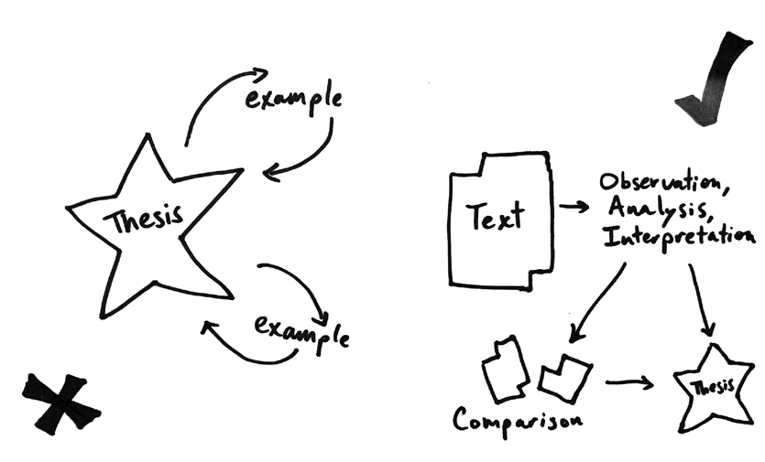

III. Thesis Statements

A good thesis needs two fundamental qualities: it needs to be doable and arguable. That is to say: the best essays are the ones that have a narrow scope and a bold argument.

The best strategy for this is to ask yourself one of the following questions…
- What specific problem or question is my thesis answering?
- What misreading of the text am I trying to pre-empt or correct? Or: what is a casual reader likely to miss?
- How would a reasonable person disagree with my thesis? How could I convince that person?

Note: Convention has it that a thesis statement should be a single sentence at the end of your Intro. As essays get longer and more complicated, you can be more flexible: your thesis could be a bit longer, or a bit spread out across the intro, so long as you’re clear about what you’re arguing.

IV. Quotes and Analysis

Avoiding “drop quotes.” Sometimes, writers think they need to cut up quotes into small pieces to fit them into their own syntax. Sometimes, they even use brackets to make the tenses and pronouns consistent. This tends to look awkward, and it obscures the language and form of the original text. Opt in favor or quoting full phrases and sentences when possible.

Using “block quotes.” To do an extended close-reading, you may in fact need to give your reader an extended piece of text. With quotes of 3 or more lines, my preferred formatting is to indent and single-space the passage.

V. Structure

X. The five-paragraph “flower.” American schools zealously promote the five-paragraph essay, in which each body paragraph uses a different example to prove the same point. The problem: that means each body paragraph is inessential on its own. If we re-think the plant metaphor, each paragraph should sprout from the previous one, allowing your overall argument to grow upward.

X. The “hamburger.” American schools also often describe essay structure as a “hamburger,” in which the Intro and Conclusion are the buns. The problem here: if the Intro and Conclusion repeat the same material, you lose the sense that you’ve made any progress from start to finish. Don’t waste time repeating bread-like generalities: bite right into the meat of the problem at the start, and give us something new to try at the end.

✓. The “staircase.” I prefer to think of a paper as a staircase. Start by swinging open the door: your title and intro should give us an immediate sense of where we’re headed. From there, body paragraphs act as steps in your argument, building evidence and claim upon evidence and claim. The last body paragraphs of the paper should, then, have some of your best readings and best arguments. After that, the conclusion gives you a window from a new floor: what can we see about the text now, from this vantage point, that we couldn’t see at the beginning?

The “staircase” can be remodeled as necessary. You might still sometimes want to use multiple examples to prove the same claim, even if that doesn’t immediately take you to the next “step.” You can also pause in the middle of the paper to take stock of how far you’ve climbed. And you’re encouraged to address objections and counter-arguments to your claims as you go along. In other words, your staircase may have additional landings, or it might spiral in a new direction, so long as it keeps rising toward your best readings and final insights.

